Barnsley Fractals
We have read about professor Michael Barnsley a while ago when we saw Iterated Function Systems. He and his students introduced IFS Fractals to the world. In his book ‘Fractals Everywhere’, he is describing about another type of fractal where we use two iterations in place of one for the next iteration based on the value of z after each iteration. The implementation method in Excel looks similar except that the iterating formula will have a condition checking too.
The First Barnsley Fractal
The first Barnsley Fractal is defined as follows
z_{n+1}=cz_{n}-c when the real part of z_{n}>=0
=cz_{n}+c otherwise
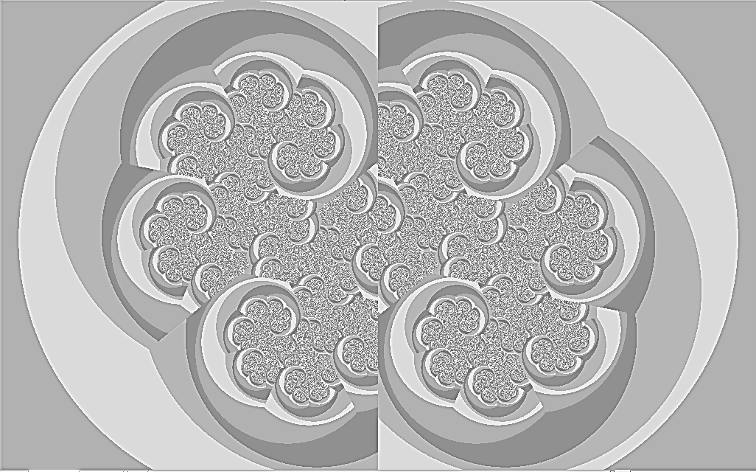
First Barnsley with 3 colour 4 gradient pallete
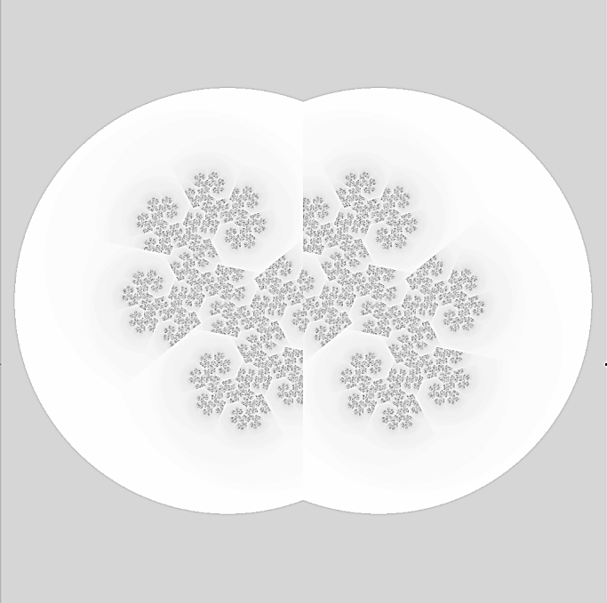
First Barnsley with 3 colour 128 gradient pallete
The second Barnsley fractal is defined as
z_{n+1}=cz_{n}-c when the imaginary part of cz_{n}>=0
=cz_{n}+c otherwise

Second Barnsley with 3 colour 4 gradient palette
We generated the fractals with a Julia like expansion.
The third Barnsley is defined as
z_{n+1}=z_{n}²-1 when the real part of z_{n}>=0
=z_{n}²-1 +p real(z_{n}) otherwise
Here the fractal generation is done with Julia type expansion while taking only the real part of c, i.e. p.

Third Barnsley

Excersise
Generate a Barnsley Sierpinsky Triangle with resolution 300x300 within the coordinates xmax=1.3, ymax=1.22, xmin=-0.5, ymin=-0.22. The maximum value of z_{n} can be restricted to 4 and maximum number of iterations is 32. The equations involved are
z_{n}=2z_{n-1} – i when imaginary part of z_{n-1} < 0.5
or otherwise
z_{n}=2z_{n-1} – 1 when real part of z_{n-1} < 0.5
or otherwise
z_{n}=2z_{n-1}
(You can create a data table from G20 till KU20 for X coordinates and F21 till F321 for Y coordinates.)
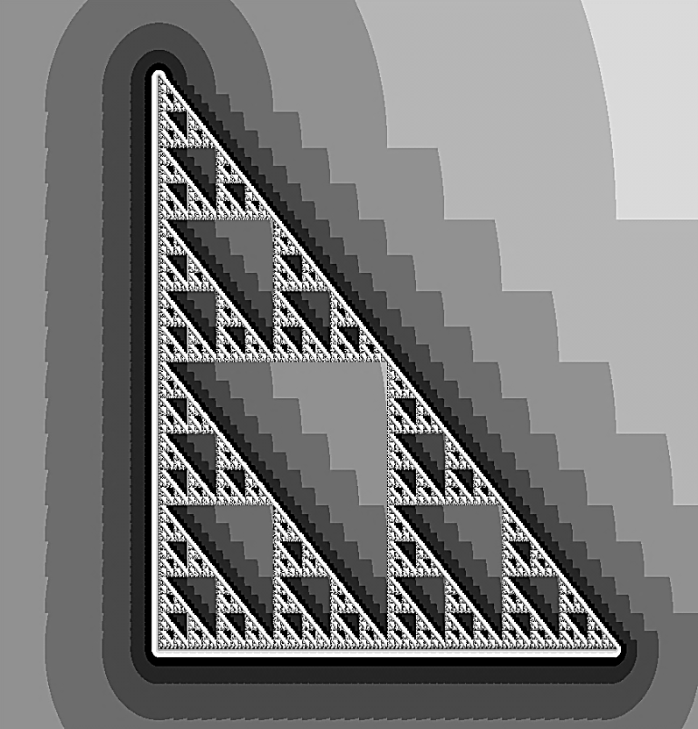
Barnsley Sierpinsky Triangle

